Screenshots or program listings must be copied into appropriate cells in the following table.
Save this evidence document as evidence_ followed by your centre number_ candidate number, for example, evidence_ zz999_9999 and insert your name, candidate number and centre number into the header above.
Examiners must be able to read the contents including any screenshots without the use of a magnifying glass. Answers that are not readable or are missing will not be awarded any marks.
Save this evidence document at regular intervals, for example every 10 minutes.
Question 1
Part 1(a)(i)
{def IterativeVowels(Value):
Total=0
LenghtString=len(Value)
for x in range(0,LenghtString):
FirstCharacter=Value[0]
if FirstCharacter=="a" or FirstCharacter=="e" or FirstCharacter=="i" or FirstCharacter=="o" or FirstCharacter=="u":
Total=Total+1
Value=Value[1:LenghtString]
return Total
}

Part 1(a)(ii)
{Temp=IterativeVowels("house")
print("Iterative",Temp)
}

Part 1(a)(iii)
{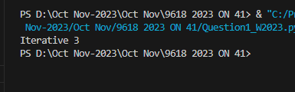 }

Part 1(b)(i)
{def RecursiveVowels(Value):
if len(Value)==0:
return 0
else:
FirstCharacter=Value[0]
if FirstCharacter=="a" or FirstCharacter=="e" or FirstCharacter=="i" or FirstCharacter=="o" or FirstCharacter=="u":
Value = Value[1: len(Value)]
return 1 + RecursiveVowels(Value)
else:
Value = Value[1: len(Value)]
return 0 + RecursiveVowels(Value)
}

Part 1(b)(ii)
{Temp=RecursiveVowels("imagine")
}

Part 1(b)(iii)
{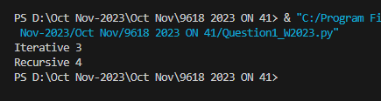 }

Question 2
Part 2(a)(i)
{#DECLARE Queue:ARRAY[0:49]OF STRING
global Queue
global HeadPointer
global TailPointer
Queue=[""]*50
HeadPointer=-1
TailPointer=0
}

Part 2(a)(ii)
{def Enqueue(DataToAdd):
global Queue
global TailPointer
global HeadPointer
if TailPointer==50:
print("Queue is Full")
else:
Queue[TailPointer]=DataToAdd
TailPointer=TailPointer+1
if HeadPointer==-1:
HeadPointer=0
}

Part 2(a)(iii)
{def Dequeue():
global Queue
global HeadPointer
global TailPointer
if HeadPointer==-1:
print("Queue is Empty")
return "Empty"
else:
DataToReturn=Queue[HeadPointer]
HeadPointer=HeadPointer+1
if HeadPointer==TailPointer:
HeadPointer=-1
TailPointer=0
return DataToReturn
}

Part 2(b)
{def ReadData():
try:
File=open("QueueData.txt","r")
for line in File:
LineData=line.strip()
Enqueue(LineData.strip())
File.close()
except IOError:
print("File Doesn't Exists")
}

Part 2(c)(i)
{class RecordData():
#PUBLIC ID:STRING
#PUBLIC Total:INTEGER
def __init__(self,ID,Total):
self.ID=ID
self.Total=Total
}

Part 2(c)(ii)
{#DECLARE Records:ARRAY[0:49]OF RecordData
#DELCARE NumberOfRecords:INTEGER
global Records
global NumberOfRecords
Records=[]
NumberOfRecords=0
for x in range(50):
Records.append(RecordData(" ",0))
}

Part 2(c)(iii)
{def TotalData():
global Records
global NumberOfRecords
DataAccessed=Dequeue()
Flag=False
if NumberOfRecords==0:
Records[NumberOfRecords].ID=DataAccessed
Records[NumberOfRecords].Total=1
Flag=True
NumberOfRecords=NumberOfRecords+1
else:
for x in range(0,NumberOfRecords):
if Records[x].ID==DataAccessed:
Records[x].Total=Records[x].Total+1
Flag=True
if Flag==False:
Records[NumberOfRecords].ID=DataAccessed
Records[NumberOfRecords].Total=1
NumberOfRecords=NumberOfRecords+1
}

Part 2(d)
{def OutputRecords():
global NumberOfRecords
for x in range(NumberOfRecords):
print("ID",Records[x].ID +" "+ "Total",Records[x].Total)
}

Part 2(e)(i)
{ReadData()
while HeadPointer!=-1:
TotalData()
OutputRecords()
}

Part 2(e)(ii)
{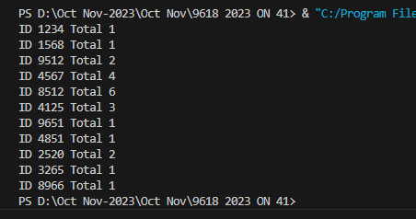 }

Question 3
Part 3(a)(i)
{class Character():
#PRIVATE Name:STRING
#PRIVATE XPosition:INTEGER
#PRIVATE YPosition:INTEGER
def __init__(self,Name,XPosition,YPosition):
self.__Name=Name
self.__XPosition=XPosition
self.__YPosition=YPosition
}

Part 3(a)(ii)
{ def GetXPosition(self):
return self.__XPosition
def GetYPosition(self):
return self.__YPosition
}

Part 3(a)(iii)
{ def SetXPosition(self,NewXPos):
if NewXPos <0:
NewXPos=0
elif NewXPos>10000:
NewXPos=10000
def SetYPosition(self,NewYPos):
if NewYPos<0:
NewYPos=0
elif NewYPos>10000:
NewYPos=10000
}

Part 3(a)(iv)
{ def Move(self,Direction):
if Direction=="up":
self.__YPosition=self.__YPosition+10
elif Direction=="down":
self.__YPosition=self.__YPosition-10
elif Direction=="left":
self.__XPosition=self.__XPosition-10
else:
self.__XPosition=self.__XPosition+10
}

Part 3(b)
{Jack=Character("Jack",50,50)
}

Part 3(c)(i)
{class BikeCharacter(Character):
def __init__(self,Name,XPosition,YPosition):
super().__init__(Name,XPosition,YPosition)}

Part 3(c)(ii)
{ def Move(self,Direction):
if Direction=="up":
super().SetYPosition(super().GetYPosition()+20)
elif Direction == "down":
super().SetYPosition(super().GetYPosition() - 20)
elif Direction == "left":
super().SetXPosition(super().GetXPosition() - 20)
elif Direction == "right":
super().SetXPosition(super().GetXPosition() + 20)
}

Part 3(d)
{Karla=BikeCharacter("Karla",100,50)
}

Part 3(e)(i)
{userchr=input("Enter the character you want:")
userdir=(input("Enter the direction you want to move:"))
if userchr=="Jack":
Jack.Move(userdir)
x=Jack.GetXPosition()
y=Jack.GetXPosition()
print("Jack's new position is X=",x,"y=",y)
else:
Karla.Move(userdir)
x=Karla.GetXPosition()
y=Karla.GetYPosition()
print("Karla's new position is X=",x,"y=",y)
}

Part 3(e)(ii)
{ 

